The Process of Making Mozzarella Cheese
Name
Institution Affiliation

The Process of Making Mozzarella Cheese
Introduction
This research is to investigate the process of making mozzarella cheese which is an Italian type of cheeses. To examine the process of making mozzarella cheese, the method and the result that is obtained in the end. To be obtained by using the majorly used buffalo water or milk, and other ingredients that is known for the making of the cheese. How the end product does look like after the whole process is done. What is the reaction that takes place during the process, as to why the buffalo milk is preferred for the process of making mozzarella cheese? And Mozzarella cheese comes in different types and is known to white, thus how does the color turn to be white. And why does the mozzarella take short span after it is made, like why is it perishable? This is because mozzarella is known not last for 12 or 24 hours after it is prepared. Moreover, Mozzarella is known to be a good ingredient for the pizza making. Therefore, this topic becomes important for the understanding of the process and how the reaction that makes the Mozzarella cheese made of buffalo milk or water very quality for the understanding of the biological processes that is involved in the process. As a result, this experiment goal is to have the Mozzarella cheese made of buffalo milk and with the white color.
Methods
To make mozzarella cheese there are the important ingredients that are needed to fully have the required color and shape of the cheese. Some of the ingredients that are needed are the unpasteurized water buffalo's milk which only comes from the Campania’s buffalo milk. The procedure involves a mixture of the curd with heated whey. After that, it is then followed by the widening and reflexology of the mixture to produce the required consistency of the mixture in a process known as pasta filata. Here as the maker, I need to do the process of reflexology with my hands just like the maker bread can do until the smooth texture of the mixture is obtained. The smooth texture then forms a shiny paste, which I use to pull out the mozzarella. I typically roll the paste to form them into balls and ensure the cheese comes out to be soft because even if it has the consistency that is considered not be satisfactory. This is according to the Mozzarella di Bufala trade association.
Results
The end result comes out to the white mozzarella cheese both in the exterior and the interior regions of the cheese. With the intensified clean aroma that has the medium sweet taste. The texture of the mozzarella cheese should be soft and the cheese met that requirement, it is soft.
Discussion
Making the Mozzarella cheese requires the understanding of the procedures that are involved in order to obtain the required result. The results can be altered when one of the procedures is not well met. During the experiment, the white color of the cheese is obtained when the water buffalo’s milk is used in the mixture failure to which the required color cannot be obtained as the procedure requires. My mozzarella cheese obtained the soft texture because the procedure needs the paste that is obtained to be rolled into balls; the balls allow the texture to be soft and smooth. However, obtaining the aroma could have been a problem because I am not sure of the aroma that the mozzarella cheese but from my experiment, I achieved the intensified clean aroma. This means that a room for the further experiment can be conducted to investigate the mozzarella cheese aroma. However, in the process, it was difficult to know exactly what comes first in the mixture, as a result, I mixture all the mixtures together to have the required paste which I used to make the balls. Then as the result of this, the end result of the texture was obtained. More problems were encountered in order to reach and have the results, the paste could not reach the required level and so I had to carry out another experiment through measuring the ingredients consistently until the paste is ready to make the balls. This is because the part of the balls explains and gives the required texture of the cheese. According to the Mozzarella di Bufala trade association, the paste can be rolled into balls or to plait to form treccia. But he I resolved to have the paste rolled to balls because it was a bit easier to form compare to making the treccia. I concentrated more on the color, the texture, and the aroma because they form the basis of the Mozzarella cheese. And through the color, the cheese can be differentiated from other cheese. The balls that I rolled were in the shape of 100 grams each in several numbers of rolled balls which all had the same texture and color. The picture below shows the color and texture of the Mozzarella cheese made and has been marinated with a coriander leaf to appear well presented.
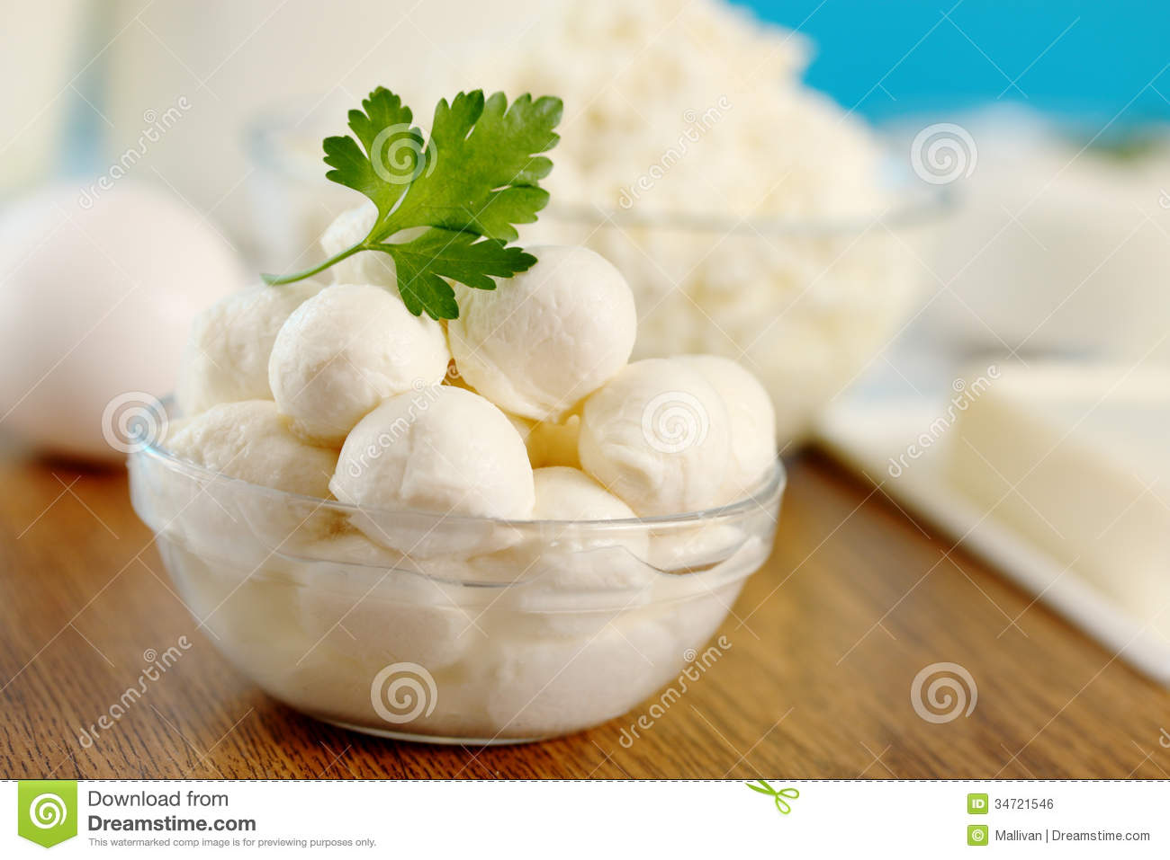

Conclusion
The whole process of making the Mozzarella cheese is supposed to be followed and the part of using the water buffalo milk was the core of the experiment because the whole process needs the involvement of every procedure. It stood clear that to get the required color and texture, the buffalo milk is necessary. Although there is the option for the cow milk, the buffalo milk works best. To gain the required results and the procedure that is involved, I learned that there is need to take control of what I am doing and give it my best to obtain the result. Cooking is a process that needs to be undertaken as a serious science because every process has to be followed promptly. Biology all the processes mean something for the reactions to take place and obtain the end result. Most interestingly about making the mozzarella cheese is the science behind the making of the cheese, the milk that is obtained from the Buffaloes can be kept and be used in order to give delicious milk through preserving it. This is because there are bacteria, enzymes and the acids that are involved and therefore, resulting in different effects to milk. But when the milk is turned and used especially in the overall making of cheese, the milk is preserved and can take longer. However, Mozzarella cheese does not take long because of the biological process which can be affected by the weather but this will depend on how the cheese is preserved. Some of the biological processes that are involved that can affect the quality include the place where the milk or the feed of the milk is obtained and even the bacteria. Therefore, I agree with the terms of Michael Pollan which states that “To learn how to cook is to put yourself on the intimate terms with the laws of physics and chemistry, as well as the facts of biology and microbiology.” This is because every process of cooking requires the understanding of the type of reaction or the microbes that are involved in the process. Conducting the wrong process will result in the obtaining of the wrong results.

